Part 1: To develop a website and host on Xampp

Step 1: Visit the official XAMPP website.Choose the appropriate version that matches your operating system, and download the compatible installer.

Step 2: Once the installation is complete, open the XAMPP Control Panel.Start the Apache server by clicking on the "Start" button next to "Apache."

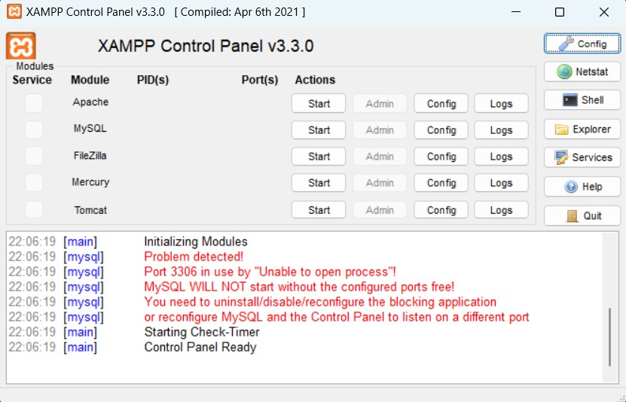

Step 3: Create a new PHP project file and save it in the "htdocs" folder, which is located within the XAMPP directory

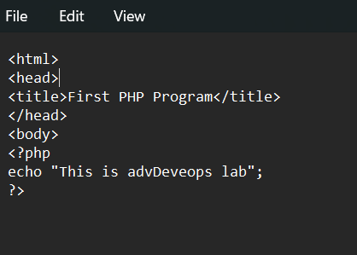

Step 4 **:** Start the XAMPP server and access your project.Go to your browser and navigate to localhost/filename.php to view your PHP file's output.

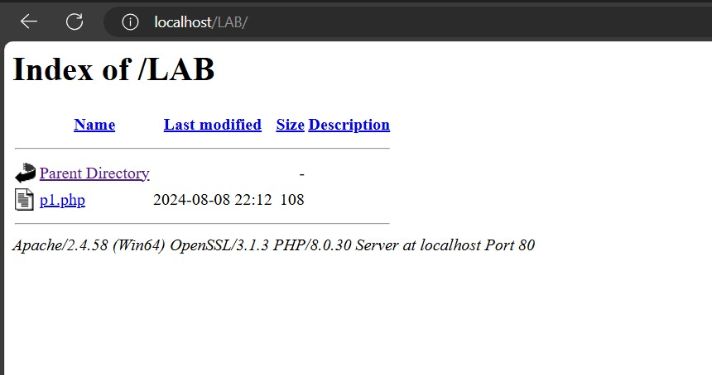

Output:

